Report 1: What is a Rover?
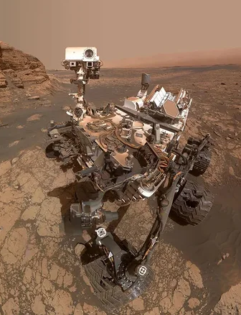
Satvik Singh | Sep 13, 2026
Image source: NASA/JPL-Caltech/MSSS

What is a robot?
A robot is a reprogrammable machine which uses sensors to orient itself in its environment, and is capable of doing necessary computations to do some predefined task , then do it .

What is a rover?
A rover is a specialized mobile robot designed for deep-space planetary surface exploration and to conduct in-situ scientific research (NASA).

Difference Between a Robot and a Rover
By definition every rover is a robot
A robot is a bucket term encompassing a large category of machines capable of automated sensing, computation, and action . ranging from stationary manufacturing and assembly arms to consumer appliances (like roombas).
A rover is a highly specialized, mobile autonomous system engineered specifically for planetary surface exploration.
Its characteristics include anit fragility and extreme resilience ,the ability to function completely unassisted, in a decentralized manner, with complete autonomy and navigate complex hazardous alien terrain and complete tasks assigned to it, expecting communication delays and breakage.
It's a complex system, a moving lab, with all parts necessary to do in situ research, collect data, and send back results and information to home base.

Why resilience and automation are important
Operating on alien terrain presents extreme operational challenges that make resilience and high autonomy necessary
Requirement for autonomy :: Data communication between planets is extremely difficult, not always consistent , low bandwidth and inherently of extremely high latency (for example even light takes 3-22 minutes to reach mars from earth making manual control impossible)make it necessary to have robust mapping, hazard detection and navigation on the rover
Requirement for resiliency and high survivability:: Rovers must be built with resilience and anti-fragility as the operational parameters include unknown terrain , and climatic conditions , high variability in temperature.
Additionally the lack of weathering phenomena (such as atmosphere, wind, and water) on airless celestial bodies, which leaves rocks into exceptionally sharp, abrasive shards and jagged particles due to micrometeorite impacts, posing a severe mechanical challenge for rover wheels, joints, and seals.
Unstructured Terrain Navigation:: Rovers must traverse unmapped alien terrains, scaling steep slopes, crossing loose regolith, and clearing large obstacles without risking tipping or rollover.

Parts of a rover
Rocker-Bogie Suspension & 6-Wheel Geometry: Rovers utilize a six-wheel rocker-bogie mechanism to maintain ground contact, distribute mass evenly, prevent tipping, and climb obstacles larger than their wheel diameter.
Chassis & Center of Gravity: A low-slung chassis lowers the center of mass, ensuring stability on steep crater walls and loose regolith slopes.
Warm Electronics Box (WEB): Insulated housing with internal heating shields, computing systems, batteries, and electronics from extreme thermal swings and space radiation.
Elevated Sensor Mast: Positions navigation cameras and spectrometers high up to expand visual range, improve stereo vision, and detect hazards.
Articulated Robotic Arm: Extends heavy payloads, tools, and drills directly to targets without requiring whole-vehicle maneuvers.
Nuclear Power Generators (RTGs): Convert radioactive isotope decay heat (Plutonium-238) into electricity, providing steady power regardless of solar proximity, dust storms, or night cycles.
Solar Arrays & Energy Storage: Recharge battery banks (lithium-ion) with advanced power management to regulate output and dynamic loads.
Thermal Control Systems: Combine aerogel insulation, thermal blankets, radiant heat sinks, and active fluid loops to maintain safe component operating temperatures.

Sensors in a rover

Cameras and Imaging
Mastcam: Mast-mounted pair of cameras capturing true-color images, video, and multispectral landscape data.
MAHLI: Hand lens imager on the arm taking extreme closeups of rock and soil textures under white/UV LEDs.
MARDI: Downward-facing descent imager recording high-resolution footage of terrain during landing.
Navcams & Hazcams: Engineering cameras providing 3D stereo vision for autonomous navigation and hazard avoidance.

Spectrometers and Chemical Analysis
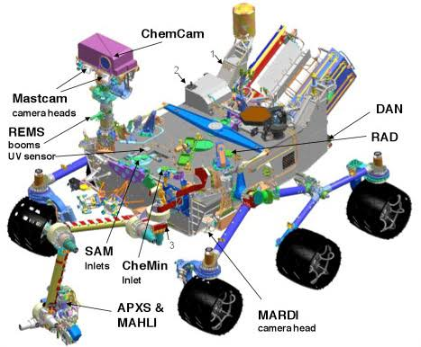
ChemCam: Fires a laser to vaporize rocks up to 7 meters away and uses a LIBS spectrometer to analyze elemental composition.
Image source: NASA/JPL-Caltech
APXS: Arm-mounted spectrometer measuring chemical makeup and trace elements via alpha particles and X-rays.
CheMin: Identifies specific minerals in drilled rock samples using X-ray diffraction.
SAM: Onboard laboratory that heats soil/rock samples to detect organics, methane, and isotopes via mass and laser spectrometry.

Environmental and Radiation Sensors
RAD: Measures surface radiation levels to assess environmental conditions for future human exploration.
DAN: Detects subsurface hydrogen and potential water/ice deposits by shooting neutrons into the ground.
REMS: Environmental station monitoring atmospheric pressure, humidity, UV radiation, wind speed, and temperatures.
MEDLI: Sensors embedded in the heat shield measuring atmospheric pressure and heat loads during entry and descent.

Autonomous tasks rovers are expected to perform
Autonomous Navigation & Path Planning: Uses stereo imagery and pathfinding algorithms (e.g., AutoNav) to evaluate terrain, bypass obstacles, and navigate hazards independently.
Target Selection & Data Collection: Employs onboard AI (e.g., AEGIS) to scan geological features, identify scientific targets, and autonomously point spectrometers or cameras.
Sample Acquisition & Caching: Controls robotic arm movement to drill rock core samples, seal them in clean tubes, and deposit sample caches on the surface.
Communication Scheduling: Manages antenna positioning, tracks satellite pass windows, prioritizes telemetry payload data, and executes data transmissions.
Health Monitoring & Self-Maintenance: Monitors power availability, regulates internal thermal conditions, runs diagnostics, and triggers safe modes during anomalies or extreme weather events.

References and Sources
- NASA Mars Exploration Program Overview: NASA Mars Exploration Program
- NASA JPL - Rover Mechanical Architecture & Components (Rocker-Bogie, Chassis, RTG Power): Perseverance Rover Design & Components
- NASA JPL - Curiosity Rover Science Instruments (ChemCam, SAM, CheMin, APXS, RAD, DAN, REMS, MAHLI, MARDI, Mastcam): Curiosity Science Payload & Instruments
- NASA JPL - Perseverance Rover Science Instruments & Heat Shield Sensors (MEDLI2, SuperCam, Mastcam-Z): Perseverance Science Instruments
- NASA JPL - Autonomous Navigation & Onboard AI (AutoNav, AEGIS Target Selection): Autonomous Navigation and Robotics on Mars
- Science Robotics Article: Science Robotics Publication (10.1126/scirobotics.adi3099)
  - General Definitions: Merriam-Webster Definition of Rover and Merriam-Webster Definition of Robot
- Robots Guide - What is a Robot?: Robots Guide (What is a Robot?)
Stargazing Mumbai - Curiosity Rover and Science Instruments: Stargazing Mumbai (Curiosity Rover)

